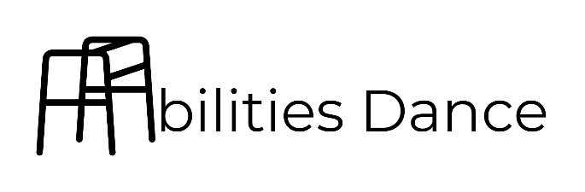
presents our third annual production entitled

Audacity

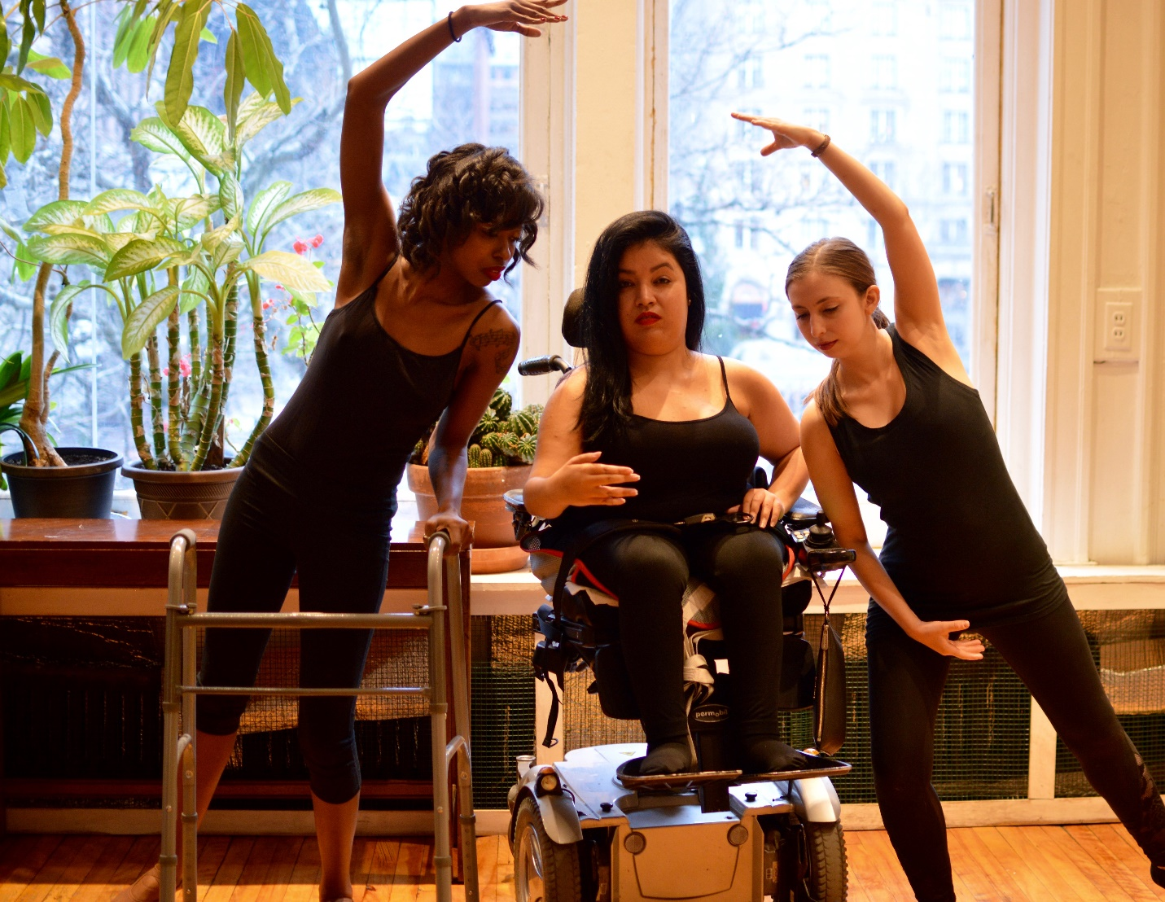
Photo taken by Victoria Awkward

Friday March 22nd, 2019 at 8 pm at the Multicultural Arts Center Cambridge, MA.

Letter from Founder/Director Ellice Patterson

Dear distinguished guest:

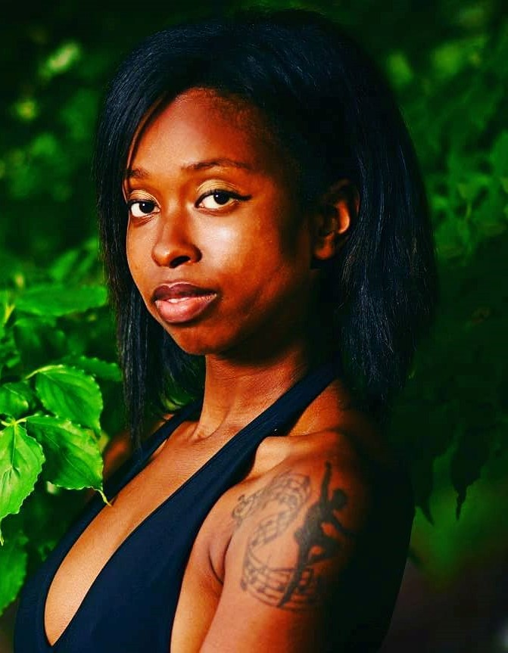
Thank you so much for coming and supporting our audacious program this evening. The whole team of audio describers, our Director of Music Andrew Choe, choreographers, and dancers have worked tirelessly to have this evening our best and boldest production yet. It is an honor to be in the Multicultural Arts Center where we had our very first show two years ago. To see the rapid growth of the performing company perform in prestigious venues and showcases in addition to the creation and expansion of our community and education programs that expands our mission to a variety of platforms has been nothing short of awe-inspiring. We have audaciously stepped into a new era of living our truth fearlessly as we break through barriers and embrace unimagined heights. We hope you continue to stay with us through this journey through continuing to come to our shows; donating your time, resources, and money if possible, to contribute to our mission; and most importantly spreading the word about this work that I am honored to lead. Please don’t hesitate to talk to me and anyone in the Abilities family to learn more of our work and how you can be involved. Thank you again for participating in Audacity. We hope you enjoy the show!

Best,

Ellice Patterson
Founder/Director of Abilities Dance Boston
Audacity
Produced by Abilities Dance Boston under the leadership of Founder & Artistic/Executive Director Ellice Patterson
Friday, March 22nd, 2019 at 8 pm
At the Multicultural Arts Center in Cambridge, MA

All music composed by Director of Music Andrew Choe

Goddesses
Co-choreographed and performed by Leslie Freeman & Ellice Patterson
Audio described by Dalton Day

(I am) Home
Choreographed by Leslie Freeman and performed by Scynthia Charles, Sarah Josselyn, & Shannon Stratton
Audio described by Dalton Day

Soccer Kids
Choreographed & audio described by Ellice Patterson
Performed by the youth of Our Space Our Place: Michael Besson, Christian Campos, Romero Huyron, Dia Miller, & Nakia Stokes

Commuting
Choreographed by Ellice Patterson
Performed by Scynthia Charles, Janelle Diaz, & Shannon Stratton
Audio described by Dalton Day

INTERMISSION

Alone, together
Choreographed by Lauren Sava
Performed by Puck Malamud, Lauren Sava, & Shannon Stratton
Audio described by Kathryn Boland
Fairy Princess Kids
Choreographed & audio described by Ellice Patterson
Performed by youth of Our Space Our Place: Mika Besson, Artenisa Osmani, Laila Ortiz Rivera
An Ending, A Beginning
Choreographed by Louisa Mann
Performed by Janelle Diaz & Lauren Sava
Audio described by Kathryn Boland

Trimodal
Choreographed & Performed by Ellice Patterson
Audio described by Kathryn Boland & Ellice Patterson

We invite you to stay after the program for Q&A with the choreographers.
This program was funded in part by the Massachusetts Cultural Council.

COMPANY BIOS

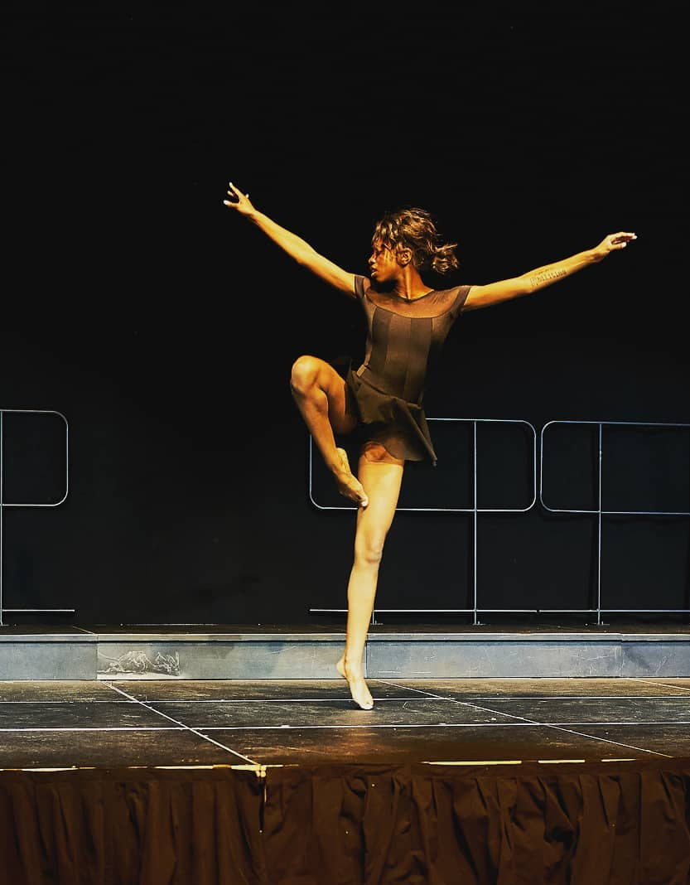
Ellice Patterson is the founder and director of Abilities Dance, a Boston- based dance company that welcomes dancers with and without disabilities. Her work in Abilities is modern focused with an adaptive twist so that dance is accessible to all. Outside of exclusively Abilities Dance's shows, her choreography has appeared in the Abilities Expo, Bill Evans Somatic Conference, Boston Contemporary Dance Festival, The Series: Vol IV at the Ailey Citigroup Theatre, and more. She has appeared in the Dove Real Beauty and Slick Chicks campaigns. She has given lectures and workshops at schools, universities, and organizations (such as McLean Hospital, Boston University, MS School for Math & Science, and more) across the country. She also earned her Bachelor of Arts in Biological Sciences from Wellesley College and her Masters of Science in Management Studies from Boston University Questrom School of Business.

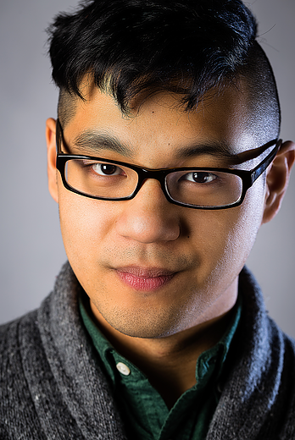
Andrew Choe is a composer and pianist with a fierce passion for visual and media scoring. He is the Music Director and Composer for Abilities Dance, and he has had the opportunity to work and collaborate with several independent filmmakers and artists. Andrew has worked as a studio assistant intern with Ryan Shore (Star Wars: Forces of Destiny, Prime, Julie's Greenroom) and he also is the Marketing Coordinator for Ensemble / Parallax, a new music and multimedia consort based in Providence, RI. He is a graduate of Berklee College of Music, and he is a recipient of the ASCAP Foundation Film Scoring Scholarship. As Music Director and Composer for Abilities Dance, Andrew is thrilled and honored to be a part of a dance platform that is all inclusive and strives to make dance accessible for all abilities.

Scynthia is a Boston based artist who recently finished her Associates in World Languages and is working towards her B.A. in Linguistics and Dance. She has always had a love of movement and exploring the capabilities of the body in her church. She participated in 2017 Skeleton Architecture. She danced in the Boston Church of Christ. I was also part of Umass Lowells step team, Steppin in Unity along with SOCA (students of Caribbean ancestry) Dance Troupe. She is excited to be working with Abilities Dance Boston in exploring movement & inclusion.

Janelle Diaz was born and raised in Massachusetts, originally from Woburn and now residing in Lowell. Janelle's love for dance began as a little girl as she admired her parents as they danced salsa "en las fiestas". The Latin beats and twisty turns inspired Janelle to learn salsa and cultivate her own interpretation of the dance as a wheelchair user. Janelle has had over two decades dancing salsa. She is now exploring her dance experience with Abilities Dance under the direction of Ellice Patterson. Janelle hopes to continue to develop her own style of dance and further highlight her Latin roots.

Sarah Josselyn is a costumer, dancer and visual artist originally from Andover, Massachusetts. She holds a BFA in Studio Art from Concordia University in Montréal, Quebec and a Certificate in Fashion Design from MassArt. She has performed as a dancer in contemporary companies as well as in burlesque troupes and productions throughout the Boston area and beyond since 2007 and has also worked in several of Boston's finest theatrical institutions, including The Boston Conservatory, Boston Ballet, American Repertory Theater and Greater Boston Stage Company. Recent costuming includes design for "Accidental Death of an Anarchist" with Praxis Stage Company, and Watertown Children's Theater. She’s an avid beach goer, cat lover, sci-fi nerd and political comedy addict. She's looking forward to more adventures with Abilities Dance and working on her portfolio for graduate school applications.

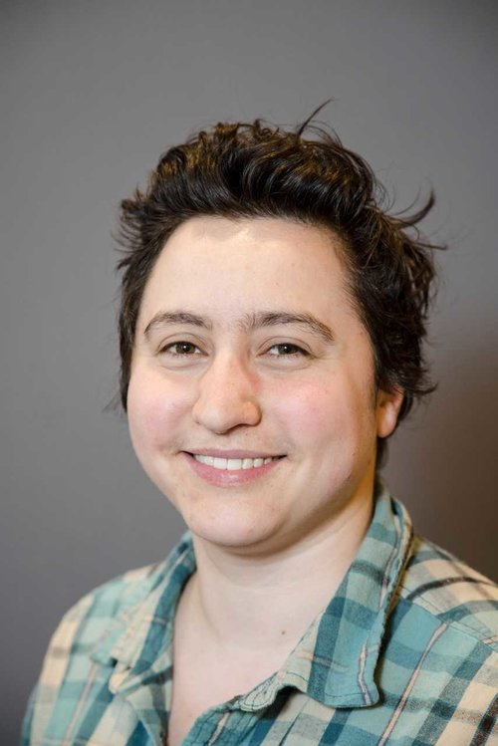
Puck Malamud (pronouns ve/ver) has been dancing since childhood, starting with ballet, then migrating to Argentine tango in high school and adulthood. Ve had given up on dancing regularly after several bouts with Lyme disease and a fibromyalgia diagnosis and is delighted to find the opportunity to dance again in an accessible and welcoming environment with Abilities Dance. Puck is a Master's student in Library and Information Science (MLIS) at Simmons College. Ve is the treasurer of the Special Library Association student chapter at Simmons and the secretary of Spectra, the LGBTQ affinity group at Simmons School of Library and Information Science (SLIS). Ve has recently been elected to the positions of co-chair of Spectra and webmaster of the Library and Information Science Student Association (LISSA).

Lauren Sava is a dancer and choreographer with Abilities Dance. Her background is in modern dance, performing and choreographing with the Ballet Performance Group in Rochester, NY, Nu Movement Cooperative in Rochester, NY, and Dance Theater Group in Boston, MA. While at Nu Movement Cooperative, she taught an eight-week modern class, “Health Awareness through Dance” and performed in Biodance's Social Justice Series. Lauren has also trained in and enjoys improv, as well as east coast swing and lindy hop. She has a Masters of Public Health in Global Health and Epidemiology from Boston University and a Bachelor of Arts in Health, Behavior, and Society from the University of Rochester. She works as a Research Assistant at Boston Children's Hospital and is passionate about social justice and yoga.

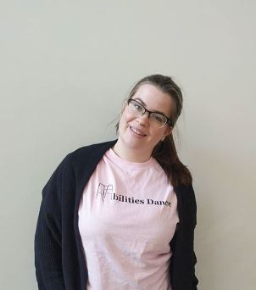
Shannon, a born Bostonian, danced through about half her childhood before taking an 8 year break from dance. In college, she decided to give dance another try at the Savannah College of Art and Design where she received her bachelor’s degree. After that class, she couldn’t imagine her life without dance and hasn’t stopped moving since. She has tried many different styles of dance including tap, jazz, swing, salsa, and hip hop but feels most at peace when dancing ballet or contemporary. When Shannon isn’t dancing, she works as a Grant Administrator at the Massachusetts General Hospital or can be found making and observing other forms of visual art.

Louisa Mann began her training in Brattleboro, VT under the direction of Kathleen Keller where she studied ballet, modern, and jazz. She has a BFA in Dance from the University of Missouri- Kansas City and is currently working on her masters in Dance/Movement Therapy at the Pratt Institute in NY. She has performed with the Albany Berkshire Ballet and Akjun Ballet Theatre as well as attended Dance Italia in Italy under the direction of Stefanie Nelson. Louisa is a company member with marked dance project and Heidi Latsky Dance in NYC.

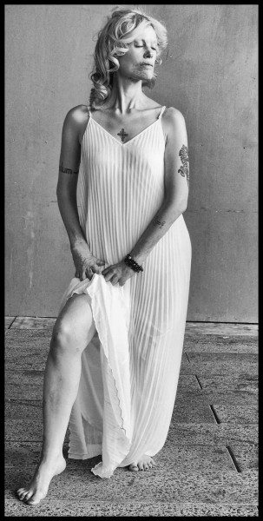
Leslie Taub is a core company member and soloist with Heidi Latsky Dance in New York City, where she also trains and performs with Infinity Dance Theater. She is inspired by her background in circus arts, and grounded by her family, especially her daughters and grandson.

SUPPORT US!

Follow us on Facebook & Instagram: @abilitiesdanceboston

Support us by shopping through Amazon Smile (smile.amazon.com) and search “Abilities Dance Incorporated” so Amazon can donate .5% of your Amazon purchases to us.

Find out more ways to donate online through abilitiesdanceboston.org/donate

Share the word of the great work we’re doing to everyone in your network.

KEEP COMING TO OUR SHOWS!

